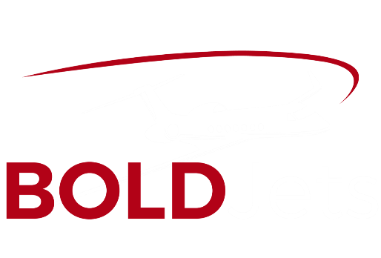
BOLDJets News
  - 9.24.21

BOLDJets Welcomes Noah Nadi to the Team!
We are very excited to add Noah to the Team. Noah’s passion for aviation roots from his childhood. That sprouted in his High School years, working at an airport at the age of 15. Shortly after, he obtained his Private Pilot Certificate at the age of 17. Being the first in aviation within his family, he strives to build lasting relationships with those around him.
“Aviation is our Passion; Client Satisfaction is our Priority.”  Contact Us:  info@BOLDJets.com  317.627.5037  1-888-351-JETS  965 Airport Access Dr.  Greenwood, IN 46143 | About Noah  Previously, Noah has worked in many different avenues of aviation including leadership roles in flight schools, jet centers, and the Department of Airports in Kern County. His dedication and passion for aviation have grown his knowledge of many different aircraft.  In his college years, he was inspired by business aviation and wanted to further his career in that field. Graduating top in his class of 2022, he will be obtaining his bachelor’s in aviation business administration. Now in BOLDJets, he is committed to assisting client needs and helping others enter the joy of aviation.  From the Owner  “I am extremely excited to welcome Noah to the Team. I met Noah in an FBO in Van Nuys earlier this year and knew he would be a good fit for the growing operations. Noah will be helping with our research and acquistiions, as well as developing into a sales role in the Turboprop categories. Noah can be reached at noah@BOLDJets.com.”  About BOLDJets  BOLDJets is an Aviation Solutions Company, specializing in Aircraft Sales & Acquisitions, assisting with Charter needs, and Aircraft management. Headquarters in Indianapolis, BOLDJets clients reach from coast to coast in the United States, as well as serving clients in Europe.

